**Project template**

**Group Alpha**

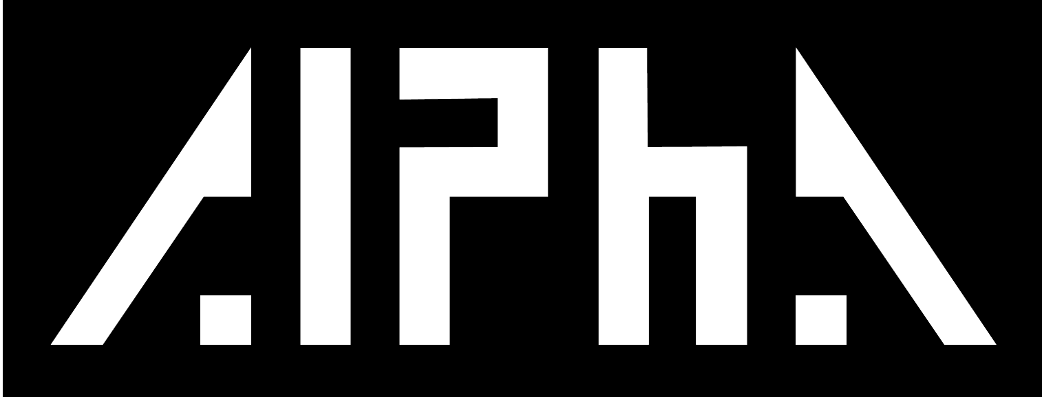

**Inhoudsopgave**

1. Planning............................................................................................................................

1.1 Mission statement........................................................................................................................

2. Project details...................................................................................................................

2.1 Project title...................................................................................................................................

2.2 Project description........................................................................................................................

2.3 Impact assessment......................................................................................................................

2.4 User requirements........................................................................................................................

2.5 Functional requirements...............................................................................................................

2.6 Dataflow diagram..........................................................................................................................

3. Implementation..................................................................................................................

3.1 Paper prototype............................................................................................................................

3.2 Figma prototype ….......................................................................................................................

3.3 Coding..............................................................................................................................

4. Testing...............................................................................................................................

5. Deployment........................................................................................................................

6. Maintenance.......................................................................................................................

**1.Planning**

**1.1 Mission statement**

**Team Mission Statement:** Creating exceptional online platforms to reinvent how people showcase their work.

**2.Project details**

**2.1 Project title**

**2.2 Project description**

Erion is a talented artist who creates a variety of art, including photography, sculpture, and painting.

He makes sculptures of the human form, miniature boats for children to play with in the lake, paintings of people and landscapes. He currently sells his artwork locally, but he wants to reach a far larger audience online.

The project involves creating a website for Erion to showcase his work. The end goal is to create a professional and compelling online presence for Erion that will attract potential clients and showcase his talent to a wider audience.

In addition to having this online platform, our client will find it simpler to present his work to his family and friends.

This project involves a team of seven (7) people.

**USER RESEARCH**

A key part of user research process is conducting interviews and surveys as they help to learn important details about the wants, needs, and expectations of users. To acquire information from the client and potential users in the context of our project, we decided to conduct an interview with the client and conduct a survey with the potential users.

**Interview with the Client:**

On the 20th of March 2023, we conducted the first interview with the client to understand the client’s needs, gather information and clarify what the client’s expectations are. During the interview with the client, we gathered the following information:

1. The client is looking for a website that showcases their portfolio and allows potential clients to contact them easily.
2. The client prefers a minimalist design with a focus on the artwork.
3. The client would like to showcase their past exhibitions and awards on the website.

**User Survey:**

We made the decision to carry out a survey in order to better understand the needs of the target audience and end users. We created a survey using the information we already had from the interview and additional research. The survey was conducted using both printed paper and Google Forms.

The team visited the Rijksmuseum and the Van Gogh Museum in Amsterdam on March 28, 2023, to distribute survey papers. With the aid of this approach, we were able to communicate with a lot of art enthusiasts. The printed survey was designed to be easy to understand, with clear and concise questions. Participants could easily complete the survey by ticking checkboxes.

We used Google Forms in addition to the printed survey to collect data from a larger audience. This method allowed us to reach individuals who were not attending art exhibitions or museums. Using a link, participants could easily access the survey, fill it out at their convenience, and submit their answers. We were able to collect a lot of data using this strategy very quickly.

We were able to connect with a wide range of people with various needs and interests by using both printed surveys and Google Forms. To gain a thorough insight of users' wants and needs, we merged the data we gathered using both methods.

The survey had the following results:

1. Most of the responses preferred a simple and minimalistic design that was easy to navigate.
2. Most responses wanted to see high quality images and descriptions of the art.
3. A contact page was important to most of the respondents.
4. Most of the responses also wanted social media integration in the website.

**Recommendations:**

Based on the insights gathered from the client interview and user survey, we will take the following into account:

1. Design: We recommend a minimalist design that puts the focus on the art. The website will be designed to be intuitive and easy to navigate.
2. Portfolio: The website will have a dedicated page for the client's portfolio with images and description of the client’s art. The portfolio will be divided into categories such as paintings, sculptures.
3. Contact page: The website will have a contact page with a form that allows potential clients to contact the client easily.
4. Artist bio: The website will have a page for the client’s bio.

**2.3 Impact assessment**

The impact assessment of the project for Erion who wants to showcase his work to a larger audience would include several potential positive impacts.

1. Improved exposure: The website would increase his exposure by making his work more available to a wider audience.

2. Improved reputation: His credibility and reputation in the art world can be improved by having a professional and aesthetically pleasing website that makes our stakeholder reach bigger audience.

3. Increased marketing and sales: The artist's website can be used as a marketing tool to draw in new customers and increase his sales.

**2.4 User requirements**

1. Contact Form: Users should be able to contact the painter directly from the website using a contact form on the page via email.

2. User-Friendly Interface: The website should be simple to use, with a clean and modern design that makes it simple for visitors to browse.

3. Mobile Responsive: The website needs to be mobile-friendly so that users may access it without any problems on their phones and tablets.

4. Creative process: The website should include engaging and informative content where users can gain a deeper understanding of the artist's work.

5. Social Media Integration: The website should include links to the painter's social media accounts, such as Instagram, Facebook, and Twitter.

**2.5 Functional requirements**

1. Portfolio Display: Users should be able to view the artist's work and browse through several categories on the website's gallery, which showcases the artist's work.

2. Artist's Biography: The artist's biography, artistic philosophies, and creative process should all be included on the website.

3. Contact: The artist's email should be included on the website's contact page.

4. Easy to use: The website should have a simple and minimalistic design.

**2.6 Dataflow diagram**

**3. Implementation**

**3.1 Paper prototypes**

**3.2 Figma porotypes**

**3.3 Coding**

**4. Testing**

**5. Deployment**

**6. Maintenance**